Mantid
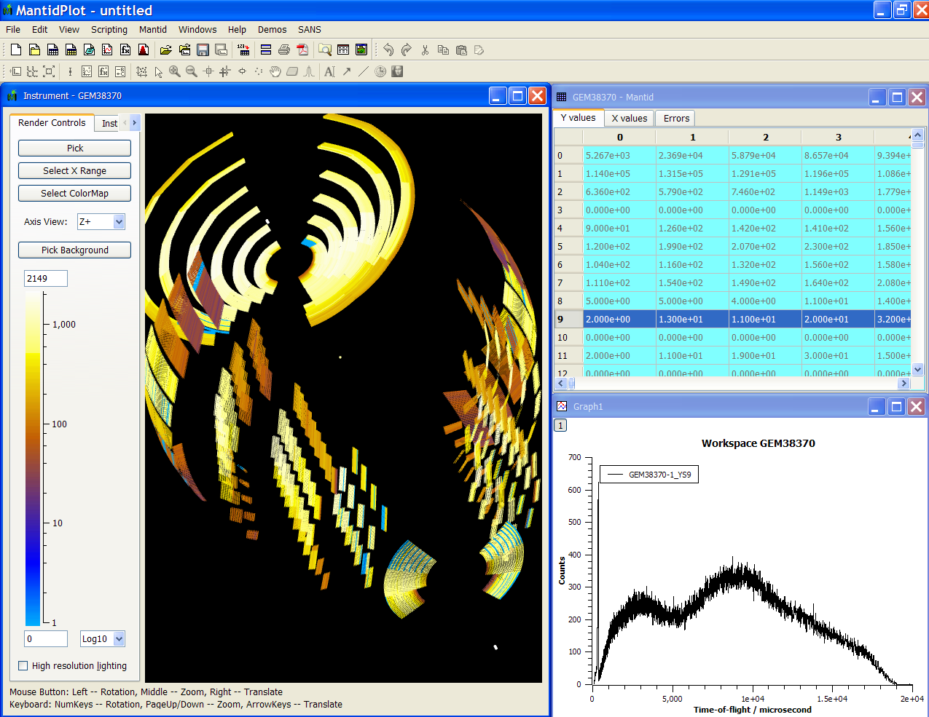
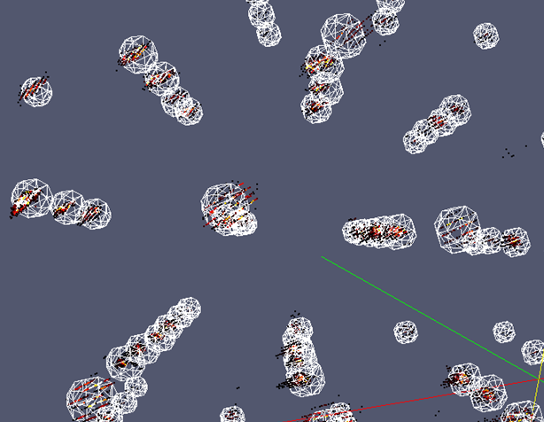
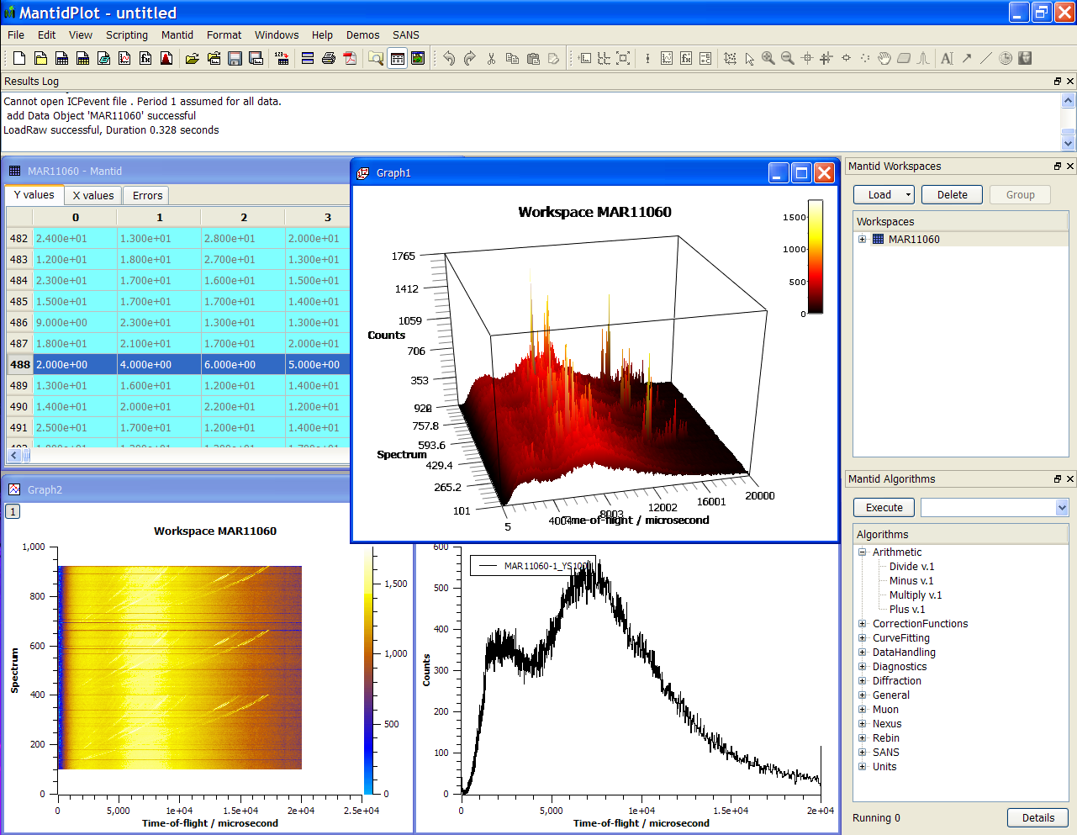
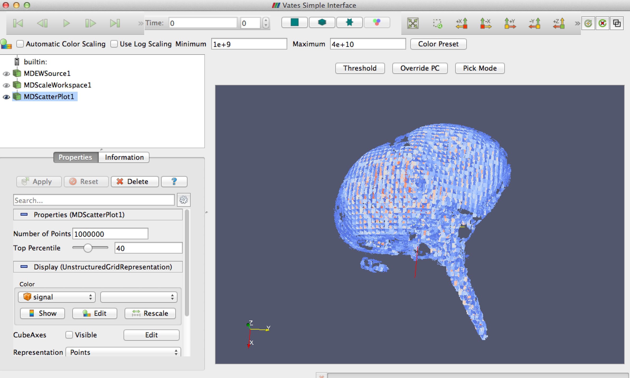
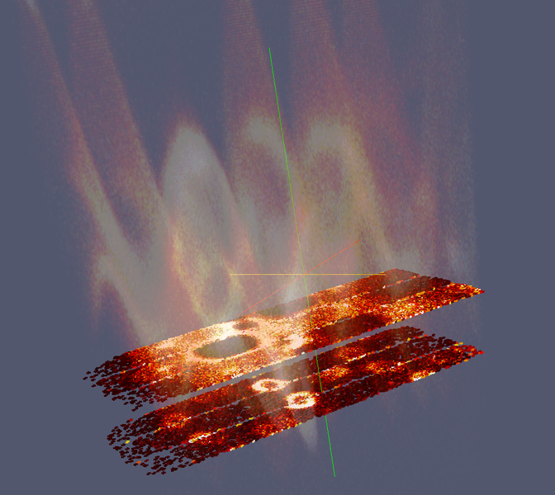
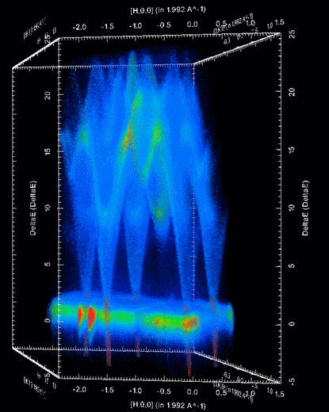
Stakeholder Engagement Plan

Document Control
This document is under document control. All members of the distribution list will receive updated copies whenever alterations are made. All other copies are uncontrolled.

Document Owner
Name | Role | Company
Nicholas Draper | Owner | Tessella

Document Approval
The following are required to approve this document. Their approval signifies that the document is fit for purpose and approved for use.
Name | Approval Role | Company
Mantid PMB | PMB | Mantid

Distribution
Name | Role | Company
Mantid Documents Repository |  | STFC

Revision History
Author | Issue | Date | Description
Keith Norman |  | 30 Sep 2013 | 1st version written from Tessella Stakeholder plan.

References
Document | Ref | Date | Details & Issue

Table of Contents
1 Stakeholder Engagement Plan 3
1.1 Project Team 3
1.2 Project Communication 3

Stakeholder Engagement Plan

Project Team
The following tables show the roles fulfilled by named individuals for the project.
ISIS Management Staff
Role | Name
Client Superintending Officer, Lead Scientist | Jon Taylor
Project Sponsor, PMB Chairman | Toby Perring
Project Customer, PMB member | Sean Langridge

ORNL Management Staff
Role | Name
Director of Scientific Computing, PMB member | Thomas Proffen
Head of Scientific Computing, PMB member | Mark Hagen
NCCS project manager, PMB member | Galen Shipman

Tessella Project Team Staff
Role | Name
Project manager | Nick Draper
ISIS Technical Lead | Martyn Gigg
Senior Developer | Roman Tolchenov
Senior Developer | Owen Arnold
ORNL Technical Lead | Russell Taylor

ISIS Mantid Developers
Role | Name
Developer, PMB Secretary | Anders Markvardsen
Developer | Gesner Passos
Developer | Karl Palmen
Inelastic Developer | Alex Buts
Graduate Developer | Peter Parker
Student Developer | Keith Brown
Student Developer | Arturs Bekasovs
Student Developer | Jay Rainey
Student Developer | Samuel L Jackson

ORNL Mantid Developers
Role | Name
Team Leader | Stuart Campbell
Team Leader | Peter Peterson
Team Leader | Mathieu Doucet
Developer | Michael Reuter
Developer | Andre Savici
Developer | Vickie Lynch
Developer | Wenduo Zhuo
Developer | Shelly Ren
Developer | Jean Bilheaux
Developer | Jose Borreguero
NCCS developer | Ross Miller

Other Tessella Stakeholders
Role | Name
Project Manager’s Manager | Paul Harrop
Project Sales Person | Richard Layne
.

Wider Stakeholders
Facility Computing Groups
Facility instrument scientist
External Software groups / projects
Non member Facilities
Industrial Partners / Users
Facility Management
Facility Users
Mantid Team

Group | Communication Path
Facility Users | Via Instrument Scientists, however this needs to be supplemented with direct communication with nominated users, presentations at user meetings, and usability testing while users are present on experiments.
Facility Management | Via Project Management Board, ISIS project management committee, and Scientific Steering Committee (see below)
Industrial Partners/Users | Via Instrument Scientists, also see the communication path for Facility users.
Non member Facilities | Direct contact between development team eg, ICNS conference.
External software groups/projects | Direct contact between development team (eg, NoBUGS conference), plus specific contact from Mantid Project Manager
Facility Instrument Scientists | Scientific Steering Committee, Mantid Project Manager engages directly at key times (eg, testing of specific functionality), ad hoc access to PM and development te3am for problem solving, working together on new functionality.
Facility Computing Group | Scientific Steering Committee ,Mantid Project Manager engages directly at key times (eg, testing of specific functionality)

Project Communication

Stakeholder Communication Plan for Key Individuals
Name: | To be determined
Responsibility: | ORNL Scientific Steering Committee Members
Comm. Path: | Annual scientific steering committee meetings, further smaller meetings as required
Mantid Staff: | Nick Draper

Name: | Tim Charlton, Francis Pratt, Jon Taylor, Pascal Manuel, Stephen King, Sanghamitra Mukhopadhyay, Kevin Knowles
Responsibility: | ISIS Scientific Steering Committee Members
Comm. Path: | Annual scientific steering committee meetings, further smaller meetings as required
Mantid Staff: | Nick Draper

Name: | Sean Langridge, Jon Taylor, Toby Perring, Mark Hagen, Galen Shipman, Thomas Proffen
Responsibility: | Project Management Board
Comm. Path: | Meetings every 4 months
Mantid Staff: | Nick Draper

Name: | Sean Langridge, Jon Taylor, Toby Perring, Debbie Greenfield, Tom Griffin
Responsibility: | ISIS Project Management Comittee
Comm. Path: | Meetings every 4 months
Mantid Staff: | Nick Draper, Anders Markvardsen

Name: | Jon Taylor
Responsibility: | ISIS Lead Scientist
Comm. Path: | Meetings monthly when Jon is available to update on the project progress and assign future tasks. Meeting minutes sent when he is off site. Frequent informal contact.
Mantid Staff: | Nick Draper

Name: | Stuart Campbell, Peter Peterson,
Responsibility: | SNS team leads
Comm. Path: | Weekly working group skype teleconferences
Mantid Staff: | Nick Draper

